PRESS RELEASE
25 October 2016
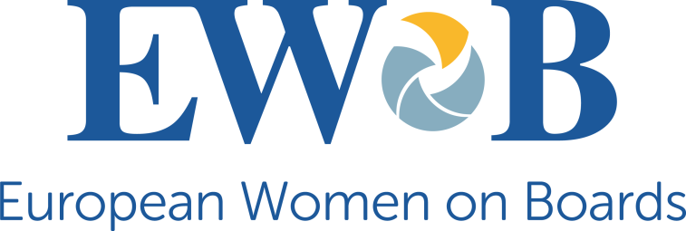

Launch of Talent Pool proves that there is no shortage of qualified women for board positions

BRUSSELS, 25 OCTOBER 2016 - European Women on Boards launches today the EWoB Talent Pool, an online database of selected, highly qualified women from across Europe, who are ready to join company boards.
The Europe-wide Talent Pool is the first of its kind, bringing together women with in-depth competences in a range of sectors and experience in decision-making at the highest levels. These board-ready women are in a position to bring real added-value to a company.
At the time of launch, on 25 October at a Brussels-based event (live-stream available here from 3pm), there are already over 150 women in the Talent Pool. These women have been endorsed by EWoB member organisations, currently present in nine European countries. As from 2017, the EWoB Talent Pool, an EU co-funded project, will be open to external candidates. Any board-ready woman who fulfils the demanding criteria will be able to apply to feature in the Pool.
All companies (public and private), NFP associations and search firms based in Europe have free access to the Talent Pool, subject to signing a Charter of Engagement.
Cécile Coune, EWoB Co-Chair and project leader, said:
'The Talent Pool puts paid to the notion that the lack of gender diversity on company boards is down to a dearth of women at the top. Each woman on the Talent Pool has been assessed according to our rigorous criteria, which means that only highly qualified and experienced women leaders are eligible for inclusion. Companies can no longer hide behind claims that there is a lack of women ready to fill transnational, non-executive directorship positions. Thanks to the EWoB Talent Pool, companies are presented with a wide selection of board-ready women to choose from.'
Marie-Ange Andrieux, EWoB Co-Chair, said:
'Today's launch of the Talent Pool constitutes a leap ahead in terms of increasing the profile and visibility of women qualified to join boards of directors. Recent reports by PwC and Credit Suisse show that there is a real appetite among directors for increasing gender diversity on company boards - not least because of its clear link with improved business performance. The EWoB Talent Pool serves as a key tool to make this diversity a reality.'
**ENDS**
Notes:
1. The EWoB Talent Pool is available here.
2. The Talent Pool is a live resource and will be regularly updated and expanded.
3. The reports cited are as follows:
- PwC (2016). The swinging pendulum: Board governance in the age of shareholder empowerment. Annual Corporate Directors Survey. Available here.
- Credit Suisse Research Institute (2016). The CS Gender 3000: The Reward for Change. Available here.
4. You can find out more about European Women on Boards here.
5. For further information and interview requests please contact: Ms Karima Zahi, EWoB Programme Director //+ 32 485 39 22 71 // communication@ewob-network.eu
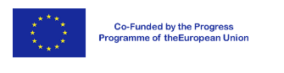
The EWoB Talent Pool has been produced with the financial support of the Progress Programme of the European Union. The contents of the Pool are the sole responsibility of European Women on Boards asbl and can in no way be taken to reflect the views of the European Commission.

